**First : Internal Analysis – Media Spot**

1. **Description of the Startup**

Media Spot is a digital marketing startup founded by a team of five passionate and skilled women, specializing in content creation and copywriting. Our mission is to help businesses effectively communicate their brand message through creative, persuasive, and high-quality written content.

What sets Media Spot apart is our ability to blend storytelling with marketing strategy, ensuring content that not only attracts but also converts audiences. Operating primarily online allows us to work flexibly with clients across industries, while weekly offline meetings ensure strategic alignment and team collaboration.

1. **Analysis of the Product or Service We Offer**

**Core Services:**

Media Spot offers premium content creation and copywriting services, tailored to meet the needs of businesses looking to enhance their digital presence. Our expertise includes:

**Social Media Content:** Engaging captions, posts, and storytelling for platforms like Instagram, Facebook, LinkedIn, and X.

**Website Copy:** Persuasive homepages, about pages, and service descriptions.

**Blog Writing:** SEO-optimized articles that drive traffic and establish brand authority.

**Marketing Campaign Copy:** Compelling advertisements, email marketing content, and promotional materials.

**Target Audience:**

Startups and small businesses seeking to establish a strong online presence.

Established companies looking to improve engagement through high-quality content.

Brands in need of storytelling-driven marketing materials.

**Value Proposition:**

High-quality, professional, and tailored content that aligns with each client’s brand voice.

A storytelling-driven approach that enhances engagement and builds audience connection.

SEO-friendly copy that improves online visibility and traffic.

Persuasive and conversion-focused writing designed to increase leads and sales.

**Competitive Edge:**

An all-female team bringing diverse perspectives and fresh creativity to content strategies.

Cost-effective services due to a digital-first operational model, allowing us to provide high-quality content at competitive prices.

A collaborative, client-focused approach, ensuring customized content that meets business goals.

1. **Manpower**

Media Spot is powered by a dynamic team of five women, each bringing expertise in different aspects of content creation and digital marketing.

**Core Responsibilities:**

**Content Writers:** Specializing in engaging blog posts, social media captions, and website copy.

**Copywriters:** Crafting persuasive and brand-aligned copy for ads, marketing campaigns, and email marketing.

**Marketing Strategists:** Developing and executing content marketing plans to attract and retain clients.

**Client Relations & Communication Experts:** Managing client interactions, ensuring clear communication, and maintaining long-term relationships.

**Operations & Project Management:** Overseeing business strategy, budgeting, scheduling, and team coordination.

Our shared vision and collaborative efforts ensure consistent, high-quality service delivery while fostering a strong team culture.

1. **Money**

**Starting Budget:**

Media Spot will launch with a budget of 70,000 EGP, strategically allocated as follows:

**Budget Allocation:**

Marketing & Promotion (40%) – Developing a professional website, running social media ads, and creating branding materials.

Operational Expenses (35%) – Subscriptions to essential tools (e.g., Grammarly, Canva, Adobe Suite) and content creation software.

Team Development & Resources (15%) – Training programs, skill enhancement workshops, and networking opportunities.

Miscellaneous & Contingency (10%) – Logistics for offline meetings, client proposals, and unforeseen expenses.

**Revenue Model:**

Media Spot will generate revenue through:

**Package-based pricing:** Offering tiered content packages based on client needs.

**One-time projects & retainers:** Flexible pricing for individual content pieces or long-term contracts.

**Custom content solutions:** Premium services for businesses with specific requirements.

By maintaining financial discipline and focusing on high-value services, Media Spot aims to achieve early profitability and sustainable growth in the digital marketing industry.

**Second : Buyer Persona**

**Basic Information :**

**Name:** Adam

**Age:** 35

**Address:**  Tanta, Gharbia

**Gender:**  Male

**Marital Status:**  Married

**Social Class:**  A, A+

**Job:** Business Owner (Doctor, Engineer, Lawyer, Professor, or Entrepreneur)

**Biography:**

Adam is a 35-year-old businessman from Tanta, Gharbia. He is married, belongs to social class A/A+, and works as a doctor, engineer, lawyer, professor, or entrepreneur. He runs his own business and is always looking for ways to enhance his brand’s visibility and growth.

**Needs & Motivations:**

Wants a reliable marketing partner to manage content creation.

Needs high-quality, persuasive copy to engage customers.

Aims to increase brand awareness, attract customers, and boost sales.

Values measurable results and ROI-driven marketing.

**Goals:**

✔ Strengthen online presence through digital marketing.

✔ Increase customer engagement and lead generation.

✔ Improve brand messaging for better conversion rates.

**Challenges & Concerns:**

⚠ Lack of understanding of his business goals.

⚠ Unclear pricing and lack of transparency.

⚠ Fear of poor communication and missed deadlines.

⚠ Security concerns over data and brand reputation.

**Personality Traits:**

Data-Driven Decision Maker

Results-Oriented

Strategic Thinker

Time-Conscious

**Skills & Expertise:**

Business Strategy: ●●●●●●○○

Financial Planning: ●●●●○○○○

Leadership & Management: ●●●●●●○○

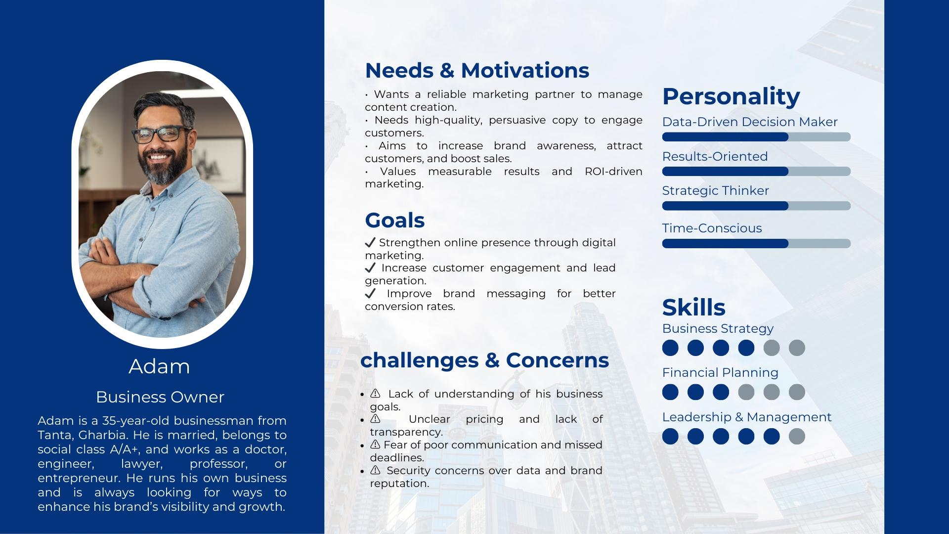

**Third : Competitor Analysis & Market Analysis**

**Competitor Analysis**

**Direct Competitors**

Media Spot specializes in content creation and copywriting, targeting businesses that want to improve their digital presence. Your direct competitors include:

1. **Local Freelancers & Small Agencies**

Many freelancers on platforms like Upwork, Fiverr, and Khamsat offer content writing and copywriting services at competitive prices.

Small agencies with similar services but a broader scope (e.g., social media management + content creation).

Strengths: Established portfolios, client reviews, flexible pricing.

Weaknesses: May lack a collaborative team approach or consistent branding strategy.

1. **Established Digital Marketing Agencies in Egypt**

Companies like Tarek Nour Communications, MO4 Network, and The TriFactory provide full-service digital marketing, including content creation.

Strengths: Strong brand presence, large teams, experience handling big clients.

Weaknesses: Higher costs, slower processes, and less personalization for small businesses/startups.

1. **In-House Content Teams in Companies**

Some companies prefer to hire full-time content creators instead of outsourcing.

Strengths: Direct brand control and dedicated resources.

Weaknesses: Higher costs for businesses, lack of fresh external perspectives.

**Your Competitive Advantage**

**All-female team:** Unique branding and fresh perspectives in content creation.

**Lower operational costs:** Your online model helps you offer competitive pricing.

**Flexibility & personalized service:** Unlike big agencies, you can provide tailored strategies.

**Focus on storytelling:** Strong emphasis on persuasive and engaging content.

**Market Analysis**

Industry Overview

Digital marketing in Egypt is growing rapidly, with businesses shifting towards online branding and content strategies.

Content marketing is a key driver for businesses looking to increase engagement and conversions.

Many businesses in e-commerce, tech startups, and traditional sectors are investing heavily in content creation.

1. **Target Market Segments**

Startups & Small Businesses (Main focus)

Need affordable yet professional content creation services.

Less likely to afford large agencies, making them ideal clients.

Often require social media content, website copy, and blogs.

1. **E-commerce & Online Businesses**

Rely on persuasive product descriptions, landing pages, and marketing emails.

Need SEO-friendly and conversion-driven copy.

1. **Corporate Brands & Enterprises**

Larger budgets but prefer agencies with strong portfolios.

Focus on long-term brand storytelling.

May require thought leadership content like whitepapers and case studies.

**Market Trends & Opportunities**

Rise in social media engagement: Brands are investing more in high-quality content.

Growing demand for Arabic & English copywriting: Many companies need bilingual content.

AI & automation tools: ChatGPT, Grammarly, and AI-driven content platforms are increasing efficiency but still require human creativity.

Video content is booming: Written content is increasingly paired with short-form videos & scripts.

**Key Takeaways & Strategy Recommendations**

1. **Positioning & Branding**

Leverage your all-female team identity as a unique brand positioning.

Highlight your personalized, creative, and affordable content solutions.

Offer specialized storytelling & persuasive content services.

1. **Pricing Strategy**

Competitive & flexible pricing to attract startups and small businesses.

Offer package deals (e.g., social media content + blog writing).

1. **Marketing & Client Acquisition**

Focus on Instagram, LinkedIn, and Facebook for B2B client acquisition.

Utilize SEO-friendly blog content on your website to rank in Google searches.

Consider partnerships with web designers, social media managers, or PR firms.

1. **Service Expansion**

Include SEO content writing to attract organic traffic for clients.

Develop additional content formats like scriptwriting for short-form videos.

Offer content audits & strategy consulting to upsell services.

**Fourth : SWOT Analysis**

**Strengths**

1. Diverse Service Offerings – Media Spot provides a wide range of digital marketing services, including social media marketing, content creation, SEO, PPC advertising, and branding solutions, catering to businesses of all sizes and industries.

2. Innovation & Creativity – The company stays ahead by implementing the latest marketing strategies, utilizing advanced tools, and experimenting with new digital trends to offer unique and effective solutions to clients.

3. Customer-Centric Approach – Media Spot prioritizes understanding client needs and tailoring customized marketing strategies to maximize their return on investment (ROI) and business growth.

4. Agility & Adaptability – As a smaller company, Media Spot can quickly adapt to new industry trends, shifting market demands, and evolving client expectations, ensuring a competitive edge.

5. Strong Industry Knowledge – The team consists of skilled professionals with expertise in various aspects of digital marketing, enabling the company to deliver high-quality services and data-driven marketing campaigns.

**Weaknesses**

1. Brand Recognition – Being a relatively new company, Media Spot is not as widely recognized as some of its larger and more established competitors, making client acquisition more challenging.

2. Limited Resources – The company faces constraints in financial and human resources, which may hinder its ability to scale operations, invest in new technology, and manage larger client projects.

3. Dependence on Key Team Members – Media Spot heavily relies on a small group of core employees with specialized skills, making it vulnerable to potential disruptions if key personnel leave.

4. Scaling Challenges – Due to its current size and resource limitations, expanding into new markets or increasing service capacity could be difficult without significant investment.

5. Limited Portfolio & Case Studies – Compared to larger competitors, Media Spot has a smaller portfolio of completed projects and client success stories, which can make attracting big clients more difficult.

**Opportunities**

1. Growing Digital Marketing Demand – The digital marketing industry in Egypt is experiencing rapid growth, with businesses increasingly allocating budgets to online advertising, presenting significant opportunities for Media Spot.

2. Rising Internet & Social Media Usage – With the increase in internet penetration and social media adoption, more businesses are shifting towards digital marketing, expanding Media Spot’s potential client base.

3. Niche Market Expansion – There is a rising demand for specialized marketing services such as influencer marketing, video content production, and AI-powered marketing strategies, areas where Media Spot can establish expertise.

4. Strategic Partnerships – Collaborating with influencers, media agencies, or tech companies could help Media Spot expand its service offerings, improve brand visibility, and attract more clients.

5. Emerging AI & Automation Tools – The rise of AI-driven marketing tools and automation software presents an opportunity for Media Spot to enhance efficiency, optimize campaign performance, and offer data-driven insights to clients.

**Threats**

1. Intensified Market Competition – The digital marketing landscape is highly competitive, with both established agencies and new startups constantly innovating and competing for clients, making differentiation crucial.

2. Rapid Technological Changes – The fast-evolving nature of digital marketing requires continuous investment in learning, training, and technology adoption to remain relevant and competitive.

3. Economic Volatility – Economic instability or financial downturns can lead to businesses reducing their marketing budgets, directly impacting Media Spot’s revenue streams.

4. Changing Consumer Behavior – Consumer preferences and digital consumption habits shift frequently, requiring constant research and adaptation of marketing strategies to maintain engagement and effectiveness.

5. Data Privacy Regulations – Stricter data protection laws and restrictions on digital advertising (such as third-party cookie bans) may impact Media Spot’s ability to collect data and run targeted campaigns effectively.

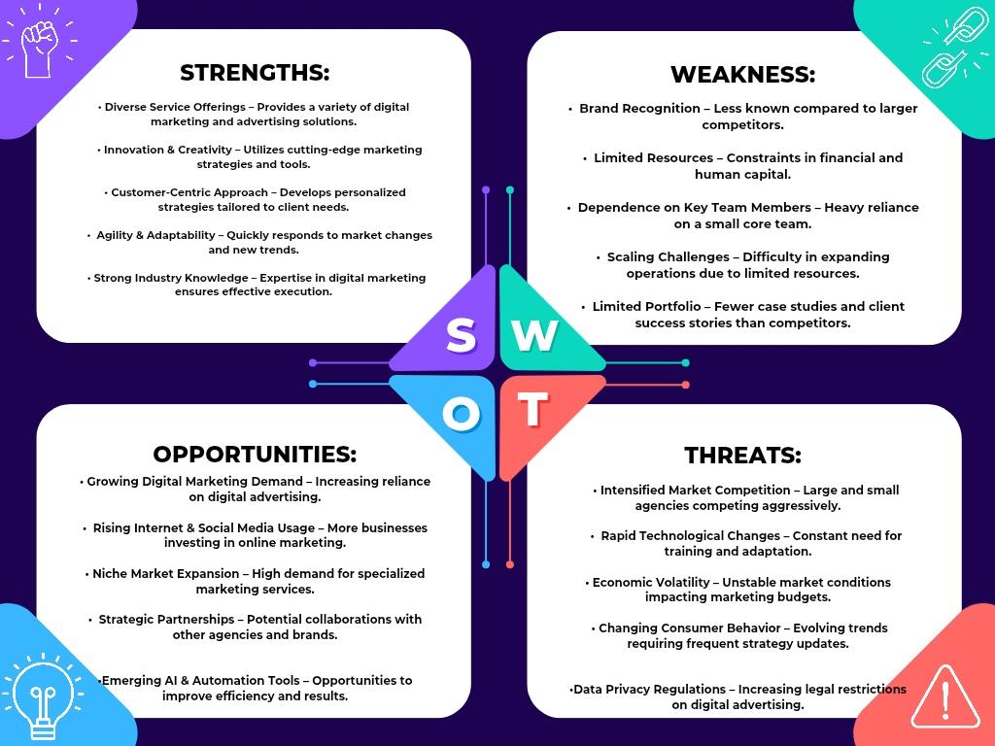

**Fifth : SMART Objectives**

**1. Increase Brand Awareness & Market Positioning**

Establish Media Spot as a recognized and credible digital marketing agency in the market.

Achieve a 40% increase in social media engagement, 30% rise in direct website traffic, and 25% growth in brand recall (measured through customer surveys) within six months.

Implement targeted digital campaigns, influencer collaborations, PR outreach, and high-quality content marketing to improve brand trust and visibility.

Conduct two industry networking events and secure media coverage in at least three reputable publications to enhance credibility.

Achieve these objectives within six months through structured marketing efforts and performance tracking.

**2. Optimize Resource Allocation & Scalability**

Enhance financial and operational efficiency to support business growth and long-term sustainability.

Reduce operational costs by 15%, improve project completion rate by 25%, and secure at least five high-value clients within 12 months.

Implement cost-effective automation tools, project management systems, and streamlined workflows to improve efficiency.

Secure at least $50,000 in external funding (grants, investments, or strategic partnerships) to support scalability efforts.

Achieve measurable improvements within 9–12 months, with quarterly evaluations to track progress.

**3. Strengthen Workforce Development & Retention**

Develop a structured employee training and retention program to enhance team skills and reduce dependency on key members.

Train at least 80% of employees on multi-functional skills, reduce employee turnover by 20%, and conduct four training sessions per quarter focused on digital marketing trends, leadership, and technical expertise.

Introduce a mentorship program where senior employees guide junior staff, ensuring knowledge transfer and long-term team stability.

Conduct quarterly employee satisfaction surveys with a target of achieving 80%+ positive feedback on work environment and career growth opportunities.

Fully implement the program within 12 months, with continuous improvement based on feedback and industry trends.

**4.Expand Services & Enhance Competitive Edge**

Differentiate Media Spot by expanding into high-demand, data-driven digital marketing services such as AI-powered marketing automation, advanced SEO analytics, and personalized content strategies.

Launch two new specialized services based on market demand analysis within six months to strengthen competitive positioning.

Increase service adoption by 30% among existing clients and attract at least 10 new clients through niche offerings.

Conduct customer research surveys and competitor analysis every quarter to identify service gaps and adapt accordingly.

Fully implement expanded services and measure success based on client retention, new client acquisition, and revenue growth within 12 months.

**Sixth : Unique Selling Proposition (USP) for Media Spot – Key Points**

• Unmatched Brand Impact – We don’t just market your brand; we make it impossible to ignore in the digital space.

• Data-Driven & Trendsetting Creativity – We combine analytical insights with cutting-edge creativity to craft high-performing campaigns.

• Targeted Audience Connection – We specialize in engaging Gen Z, Millennials, and forward-thinking brands, ensuring maximum relevance and impact.

• Agility & Innovation – As a young, dynamic agency, we adapt quickly to trends and emerging technologies to keep brands ahead. Strategic Growth Partner – More than just marketers, we act as a powerhouse for brand leadership, driving long-term success in a competitive digital world.

**( As a Paragraph ) :**

“At Media Spot, we don’t just market your brand—we make it impossible to ignore. As a bold and innovative digital marketing agency, we combine data-driven insights with trendsetting creativity to craft campaigns that captivate Gen Z, Millennials, and forward-thinking brands. Our agility, fresh perspective, and deep understanding of the digital landscape ensure your brand doesn’t just compete—it leads. With Media Spot, you get more than a marketing partner; you gain a strategic powerhouse dedicated to turning your vision into a brand that dominates the digital world.”

**Seventh : Improved Marketing Strategy for Media Spot**

1. **Target Audience**

**Primary Audience:**

Small and Medium Businesses (SMBs): Need compelling content for websites, blogs, and social media.

E-commerce Brands: Require persuasive product descriptions and ad copy to drive conversions.

Startups: Seek brand storytelling and content marketing strategies to build awareness and credibility.

**Secondary Audience:**

Personal Brands & Influencers: Need engaging social media content for audience growth and brand positioning.

1. **Brand Positioning & Messaging**

**Positioning Statement:**

“Media Spot transforms words into powerful growth tools—crafting content that captivates, engages, and converts.”

**Core Message:**

Combining creativity, storytelling, and persuasive writing to help brands communicate effectively and drive action.

Delivering data-driven, high-impact content marketing solutions tailored to business needs.

**Tone & Voice:**

Engaging, professional, and brand-focused with a balance of authority and creativity.

1. **Lead Generation & Client Acquisition Strategy**
   1. **Social Media Marketing**

Focus on LinkedIn, Instagram, Facebook, and TikTok for client engagement.

Share educational content on copywriting, storytelling techniques, and content marketing strategies.

Post before-and-after content transformations to showcase expertise.

Host interactive Q&A sessions, live copy audits, and behind-the-scenes videos to engage potential clients.

* 1. **SEO & Content Marketing**

Optimize the website for high-intent keywords like “best copywriting agency in Egypt.”

Publish SEO-driven blog posts on copywriting trends, brand storytelling, and conversion-driven content strategies.

Offer free downloadable resources (e.g., content marketing guides, headline formulas) to capture leads.

* 1. **Paid Advertising (PPC & Sponsored Content)**

Run Google Ads & LinkedIn Ads targeting businesses needing content solutions.

Launch Facebook & Instagram Ads with engaging copy to attract entrepreneurs and marketers.

Implement retargeting ads to re-engage website visitors who haven’t converted yet.

* 1. **Email Marketing & Lead Nurturing**

Build an email list through free content offers (e.g., “10 Copywriting Hacks for Conversions”).

Send weekly newsletters with industry insights, case studies, and special promotions.

Automate personalized follow-up emails with tailored service recommendations.

1. **Client Retention & Relationship Management**
   1. **Exceptional Content Delivery**

Provide customized copywriting solutions based on client goals.

Offer A/B-tested copywriting samples to maximize engagement and conversion rates.

* 1. **Exclusive Client Perks**

Offer discounts for long-term projects and repeat collaborations.

Provide free content strategy consultations for returning clients.

* 1. **Community Building**

Create a Facebook group or LinkedIn community for business owners seeking content marketing insights.

Host webinars on storytelling, email copywriting, and ad copy optimization to nurture client relationships.

1. **Innovation & Competitive Differentiation**

Develop an AI-powered content optimization tool to enhance copy effectiveness.

Offer brand voice development packages for businesses needing consistent messaging.

Create a content subscription service for businesses requiring ongoing blog and social media content.

Leverage interactive and multimedia content to differentiate from competitors.

Utilize data analytics and consumer insights to personalize content strategies for each client.

1. **Performance Tracking & Optimization**

Use Google Analytics, social media insights, and email open rates to measure performance.

Track content engagement, lead conversion rates, and client satisfaction for continuous improvement.

Conduct quarterly strategy reviews to refine marketing efforts based on performance data.

1. **Growth & Expansion Plan**

Expand services to high-growth industries such as fintech, healthcare, and real estate.

Partner with marketing agencies and PR firms for outsourced content services.

Launch a YouTube channel or podcast discussing content marketing trends and best practices.

Offer workshops and training programs to establish Media Spot as a thought leader.

Develop a referral program to encourage satisfied clients to bring in new business.

**Eighth : Content Calendar**

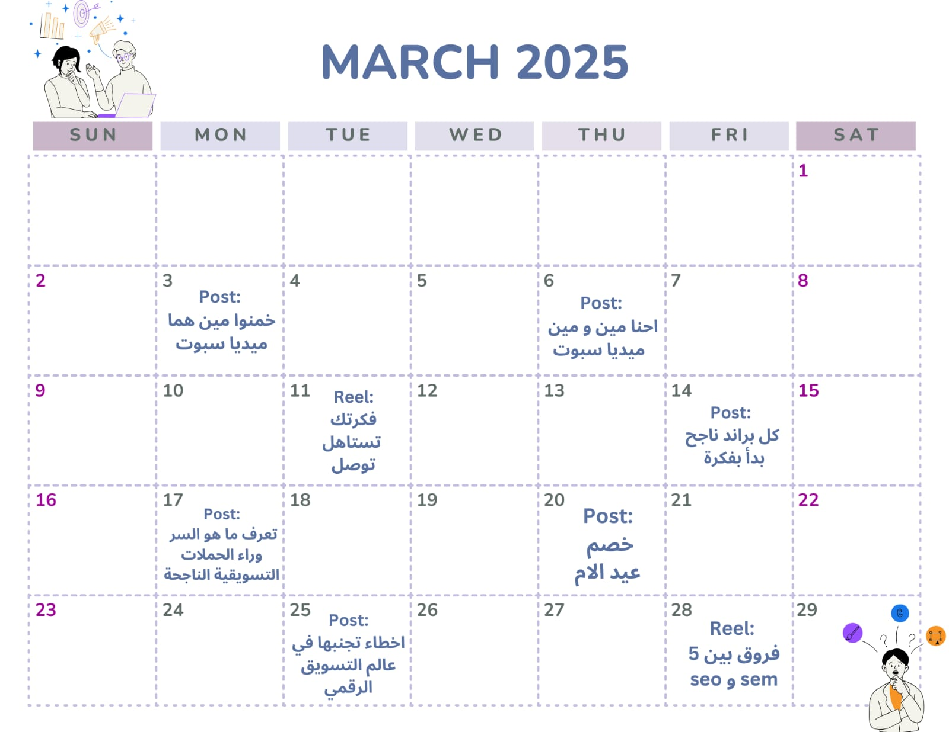

**Ninth : GANTT CHART**

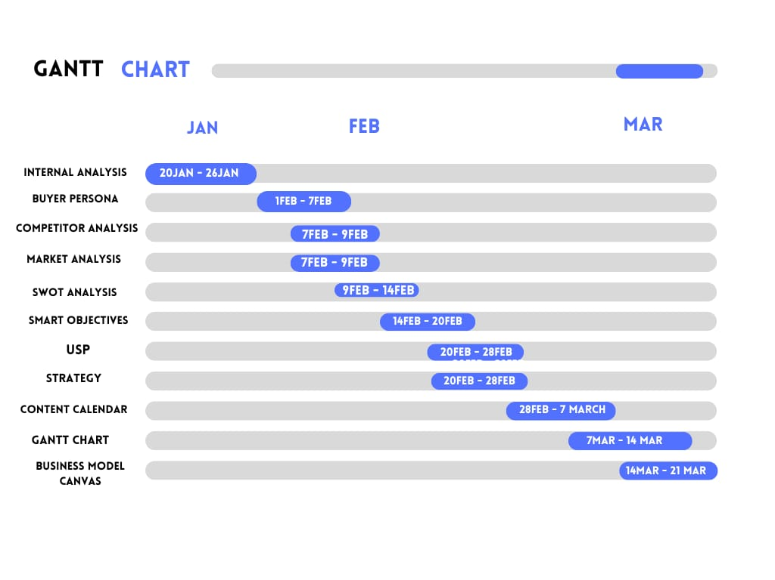

**Tenth : Business Model Canvas**

